Software Requirements Specification
for
<ONE TO MANY FILE SAHRING>
Version 1.0 approved
Prepared by <k.priyanka
<21/09/2016>
Table of Contents
1. Introduction
1.1 Purpose
1.2 Document Convention:
1.3 Intended Audience and Reading Suggestions
1.4 Product Scope
2.Overall Description
2.1 Product Perspective
2.2 Product Functions:
2.3 User Classes and Characteristics
2.4 Operating Environment
2.5 Design and Implementation Constraints
2.6 User Documentation:
2.7 Assumptions and Dependencies
3.External Interface Requirements
3.1 User Interfaces
3.2 Hardware Interfaces
3.3 Software Interfaces
3.4 Communications Interfaces
4.1 System Features 1
4.1.1 Description and Priority
4.1.2 Stimulus/ Response Sequences
4.1.3 Functional Requirements

4.2 System Features 2

5.Other Non-functional Requirements
5.1 Performance Requirements
5.2 Safety Requirements
5.3 Security Requirements
5.4Software Quality Attributes
Maintainability
Adaptability
Usability
Availability
Reliability/Availability

5.5Business Rules
Team Members
Division of work
6.Other Requirements

Revision History
Name | Date | Reason For Changes | Version
group | 21/09/16 | Intiation of project | V1.0

Introduction

Purpose
The purpose of this document is to provide the software requirement specification report for the ONE TO MANY FILE SAHRING application. It captures complete description about how the application is expected to perform. It will explain the purpose and features of the system, the interfaces of the system, what the system will do.

Document Conventions
Font is Times new roman.We have taken some Priorities for the Document Conventions .Points are denoted by '*'.font size is 12.And heading are bold and times new roman

Intended Audience and Reading Suggestions

This project is the college level project and is implementing under the guidance of college professors. This project is useful to everyone who wanted to share the files with high security. Developers need to know about the SRS to continue with.

Product Scope
The purpose of this application is to create convenient and easy file sharing to the recepients with high security .Application uses the azure storage explorer . Protect and share your files to as many people as you wish based on our state of the art
* Network Lock,
* Geo-Lock
* password
* none .
This application is One-to-Many Secured File Sharing Application which creates a virtual perimeter of access around the co-ordinate from which it was uploaded.

References
IEEE. IEEE Std 830-1998 IEEE Recommended Practice for Software Requirements Specifications. IEEE Computer Society, 1998.
Azure visit the link - https://azure.microsoft.com/en-in/services/storage/
Directory of Azure - https://azure.microsoft.com/en-us/services/
Official website - https://azure.microsoft.com

Overall Description
In this part we will describe about aim and objectives of the project. It also includes requirements and constraints of the project.

Product Perspective
It is file sharing application. Even though we are having many applications for one to many file sharing we feel insecure when we want to share that file confidentially then we hesitate . So we thought of creating something which is more secured . Protect and share your files to as many people as you wish based on our state of the art locks provided. This One-to-Many Secured File Sharing Application which creates a virtual perimeter of access around the co-ordinate from which it was uploaded.

Product Functions
* login is not required
* stores the file in cloud
* we can share this file to any number of people
*Any number of people can download file at a time if they are having acces key (if the owner of the file keeps any lock)
*3 types of locks according to the user

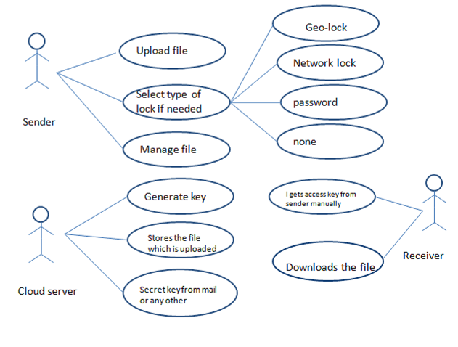
A basic diagram showing the roles of the particulars.

User Classes and Characteristics
Users of the system must be able to view or download the file if they are having the access key. The system will support two types of user privileges, owner of the file and the receiver. Owner of the file (sender) can delete the file which is stored in the cloud or he can add some other files or he can change the access key. And receiver can just view or download the file if he has access key. All the access keys and the history of the user is stored in the database.

Operating Environment
It works for any hardware like any HDD, processor, RAM. But when it comes

to software it works on Windows (8.1 to 10) and Android (4.4 to 6). This is not for Linux and IOS.

Design and Implementation Constraints
If all the users are using at a time then the speed will be down. The current version of the application does not support Linux editions, IOS.
The requirements at the designing time of that users may keep their shared data in Server’s memory for a long time, so the user should require sufficient memory in this case.
* The cloud storage provides free space of 15 gb.

* Even though the private setting can be managed easily, we should be careful that it does not expose our face or profile to unknown user.

User Documentation
*The document should be helpful for the people how to use the application and how to configure.
*Documentation should also explain how locks are worked
* The documentation must also include details regarding
The knowledge of set-up
Configuration
Maintenance
On-going management
Error recovery procedures.

Assumptions and Dependencies
*It uses azure cloud explorer so if storage space is full the we have to extend the storage space.
*It automatically deletes the files atmost after 30 days.
*If the storage is full then it deletes the file in 3 days
*Not a cross platform software

External Interface Requirements

User Interfaces
There are four primary elements
* sending and receiving buttons
*If there is any error like internet connection or storage problem or file uploading
*To lock the file
network lock
geo-lock
password
none
* The keys generated over a month are known to the user by key list

Hardware Interfaces
*This application works in pcs with windows(8.0 to 10)
*It works in android phone and windows phone also
*GPS should be in the phones for the app to be runned
*size of the file can be anything without limit but we have to check the storage space.

Software Interfaces
User can be offline while the file is being accessed by the receiver. If we apply Geo-lock for access the application verifies the location by GPS location service to provide access. If the owner applies Network lock the application verifies the SSID and provide access to the file. If the owner applies a password based lock the user has to enter the key which is generated by the application which is unique.

Communications Interfaces

* File Service allows storing and access of data on the cloud using the SMB protocol. SMB is server message block SMB is also known as common internet file system (CIFS) operates as an application-layer network protocol mainly used for providing shared access to files, printers, and serial ports and miscellaneous communications between nodes on a network. It also provides an authenticated inter-process communication mechanism.

System Features

System Feature 1 USE CASE DIAGRAM 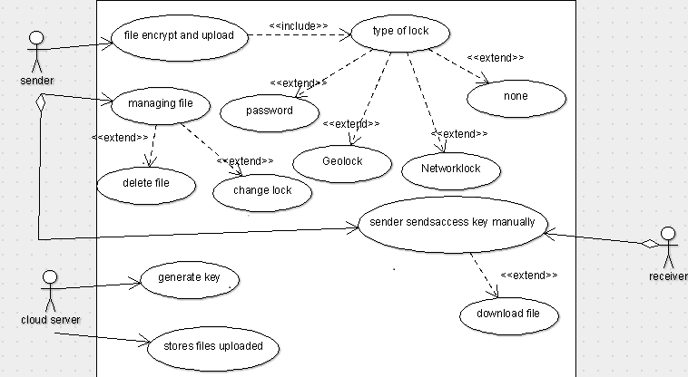
* Geo-Lock is a form to control what can be accessed where access to content is restricted based upon the user's geographical location. In a geo-lock , the user's location is calculated using GPS techniques, by this we can restrict the access to the file to certain location.
* Network Lock is a technical to restrict the access of the files to specific networks.
* Password Lock is used to protect a file with password, So unlike Geo-Lock and Network Lock, It does not depend on the user location or network.

Requirement Id Function
R0 file encrypt and upload
R1 type of lock
R2 password
R3 geo-lock
R4 network lock
R5 none
R6 managing file
R7 delete file
R8 change lock
R9 generate key
R10 stores files uploaded
R11 sends access key to receiver manually
R12 download file

4.1.1 Description and Priority
In this application we use different types of locks. we give priority to different locks at different situations .If we use network lock then the network should be secured so if the network is not so secured then we give our priority to password or geo lock. we can use password lock. we can priories lock according to our requirement.
4.1.2 Stimulus/Response Sequences
* When the owner wants to share a file with some user, first the owner of the file can select a file which will be uploaded and the owner can apply lock to the file.
* The key is saved in the list.
* The receiver has to enter the valid key and access criteria in order to get access(password, location, network).

4.1.3 Functional Requirements
* Internet
* Azure storage table
* Azure storage blob.
*Access key management
  - The key must be expired after 3 days after key is generated.
  - All the access keys the user has used are stored in the database.
* Android(4.4 - 6)
* Windows(8.0 - 10.0)

System Feature 2 (and so on)
Restrict the access to the files uploaded based on our Geo lock.
- User can be offline while the file is being accessed by the receiver.
- The files, for better security are encrypted before being saved in the servers.
- FOOL PROOF! It’s not possible to spoof the location for the Geo lock on papers.
- User-defined range of access in Geo-Lock ranging from 30 m - 250 m.
- Network Lock (WiFi based).
- For better safety, Access keys are deactivated after 30 days.

Other Nonfunctional Requirements
* GPS service
* Network adapter

Performance Requirements
Till now if a user wants to share his private data with other users that are
presently connected to the network that file is accessible for all users. Files which are shared with network lock may not be accessible but available to all the users connected the network. Same in the case of Geo-Lock. In such system we cannot control the access to one’s personal information.

Safety Requirements
Using such conventional process two users could not share their private data due
to the factor of privacy and security. So the user may use another alternative. For example geo-lock recognizes and verifies SSID of the network. For secure network it can be changed(Network spoofing).But for insecure networks the SSID can be changed. In that case Geo-Lock or Password lock is suggested.

Security Requirements

Security is the main criteria for the proposed system. Since illegal access may damage the privacy. So security has to be given in this project. The system must be secured, so that unauthentic users cannot enter in the system.

Software Quality Attributes

Maintainability:
We will be in constant implementation of the requirements according to the product backlog throughout the process of designing the program and after release of it. So we can make significant changes in the latter stages of the program for better user
interface.

Portability:
This works both in smart phones and personal computers.

Reliability/Availability: The availability of the system is a key requirement by nature. The candidate architecture must ensure failover capabilities. Targeted availability is 24x7: 24 hours a day, 7 days a week.

Business Rules

Team Members:
- Chowdavarapu.Sriker
- Loga Prakash
- Mallela Murali Manohar
- K.Priyanka
- Marthala.Supraja Reddy

Division of work:

K. Priyanka: - Analysis (Functional and Non-functional Requirements).

Marthala. Supraja Reddy: - Design (Architectural design, database design and

&

Mallela Murali Manohar interface design).

Chowdavarapu. Sriker: - Coding and Testing

&;

Loga Prakash

6. Other Requirements
* Reliability is very important.
* It has to overcome the geo spoofing techniques .
* Owner should have the capability of changing the lock type even after sharing the file

